**Parallel and Distributed Systems**

159735

Assignment one

π calculation

Wei Han

20015402

Amdahl’s Law

A program which can be parallelized can be split up into two parts:

* A part cannot be parallelized
* Another part can be parallelized

T is called total time to execute program in serial.

The time T includes the time of both the non-parallelizable and parallelizable parts.

The non-parallelizable part is called B (serial part).

The parallizable part is T - B

**T = B + (T-B)**

**(T-B)** which can be sped up by executing it in parallel

(T-B)/N

The number of threads or CPUs is called N, which can speed up the parallelizable part.

T(N) = B + (T - B) / N

If N =1 T=1 then:

T(1) = B + (T(1)-B) which seems like just one single CPU

T(1)=T(1)=1

If N =2 T=1 B=0.6 then:

T(2) = B + (T(2)-B)/2

T(2) = 0.8

If N =4 T=1 B=0.6 then:

T(4) = B + (T(4)-B)/4

T(4) = 0.7

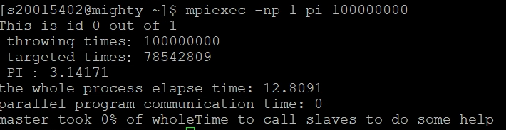

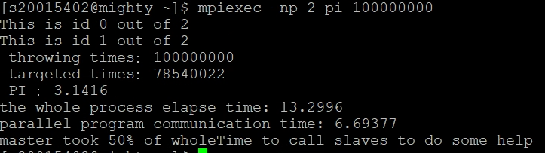

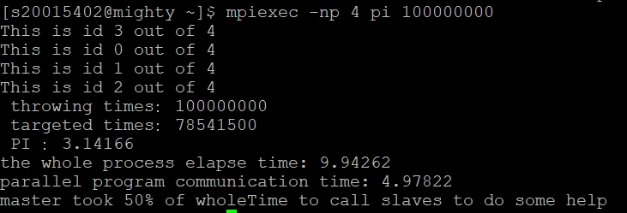

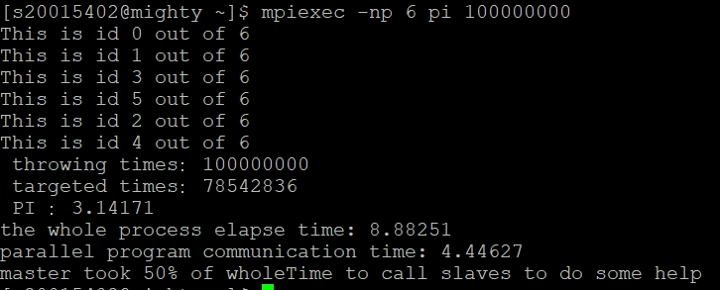

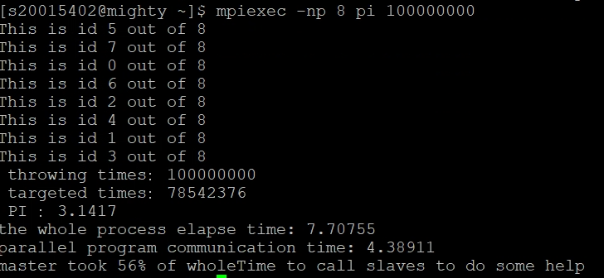

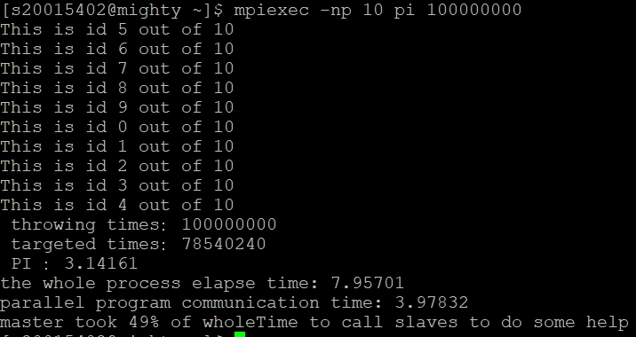

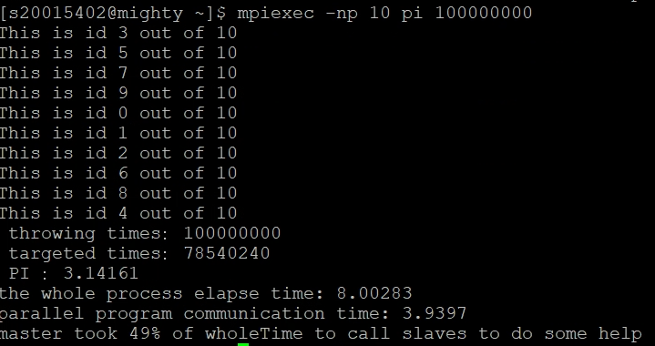

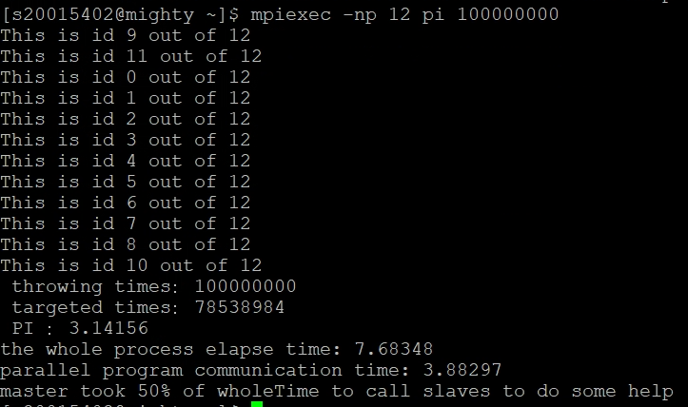

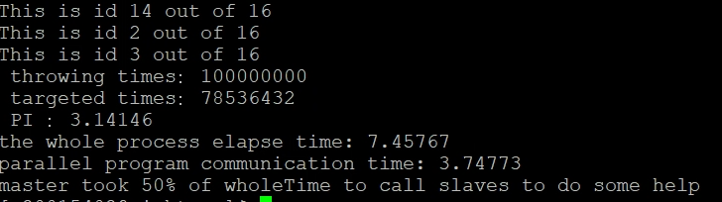

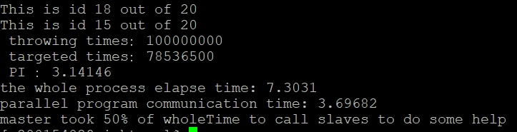

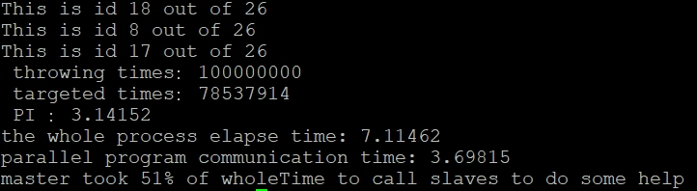

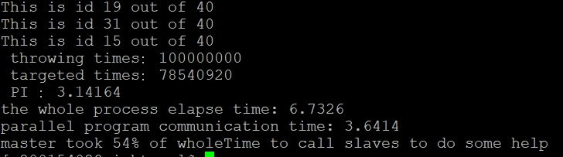

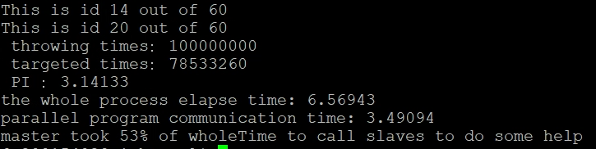

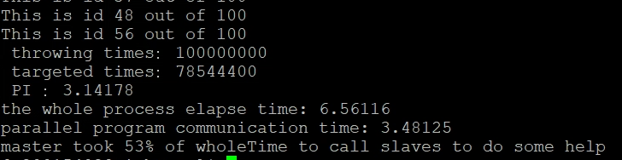

Parallel speed-ups

When we want to optimize the sequential part of a program, we need a factor O to represent that.

T(O,N) = B/O + (1-(B/O))/N

B/O is the time of sequential part.

The factor O can shorten the program execution time in sequential part.

If the time of the old version of the program is T, then the speedup will be:

SpeedUp(SU) = T/T(O,N)

When we set T = 1 then, SU= 1/ (B/O + (1-(B/O))/N)

If B=0.6 ,O=2, N=4

SU =2.1052…..the result varies according to these parameters.

It means that the original speed has been speed up by “Speed-ups” at least 2 times.

interprocess communication times